Consider the protocols, languages, libraries, frameworks, and data formats we studied this semester and write the name next to the description below. For maximum credit write the full name. But, if you only know the abbreviation, write if for partial credit.

Then, consider whether your answer describes something that is part of front-end web development (processed by the web browser), back-end development (process by the web server), or neither (supports front-end and back-end communication).

- Which language allows us to select, delete, insert and update information that is stored in a web application's database?
Structure Query Language
Circle one: Front-end Back-end Communication

- Which programming language can get information from forms and URLs, and directly pass information to database queries?
PHP Hyptertext Pre-processor
Circle one: Front-end Back-end Communication

- Which language is used to define the structural layer of a web page?
HyperText Markup Language
Circle one: Front-end Back-end Communication

- Which language is used to define the presentation layer of a web page?
Cascading Style Sheets
Circle one: Front-end Back-end Communication

- Which programming language is used to define the behavior layer of a web page?
JavaScript
Circle one: Front-end Back-end Communication

- Which programming library provides functions for selecting web page elements and appending new web page elements to a web page?
JavaScript *** not covered yet
Circle one: Front-end Back-end Communication

- Which framework is used to pass information between a web server and web browser without needing to refresh the entire web page?
Asynchronous JavaScript and XML (AJAX) *** not covered yet
Circle one: Front-end Back-end Communication

- Which data format is currently the preferred way to pass information asynchronously between a web server and web browser because of its minimal syntax for defining objects, arrays, and values?
JavaScript Object Notation (JSON) *** not covered yet
Circle one: Front-end Back-end Communication

- Which data format is the original way to pass information asynchronously between a web server and web browser but is no longer widely used because the markup is wordy and requires the overhead of creating a document type definition?
eXtensible Markup Language (XML) *** not covered yet
Circle one: Front-end Back-end Communication

- Which protocol is used to request web pages from web servers?
HyperText Transfer Protocol HTTP
Circle one: Front-end Back-end Communication

- Which protocol is used to connect to a remote server to upload and download files and scripts?
File Transfer Protocol (FTP)
Circle one: Front-end Back-end Communication

- Which of the following is the BEST example of semantic or meaningful markup?
- <div class=“left_column”>Navigation menu</div>
- <section class=“bibliography”>This is where the bibliography will go</section>
- <b>Page Title</b>
- <font type=“Arial” size=“16pt”>Page Title</font>
Explain your answer:
It tells you that the content is a bibliography, which is meaningful. The other specify only location (left column) and appearance

- Which of the following is the WORST example of semantic or meaningful markup?
- <div class=“left_column”>Navigation menu</div>
- <section class=“bibliography”>This is where the bibliography will go</section>
- <h1>Page Title</h1>
- <font type=“Arial” size=“16pt”>Page Title</font>
Explain your answer:
Only specifies appearance. Tag give content no meaning
- Which HTML element defines the visible part of a web page where text and images are placed?
<body>
- Which HTML element is used to define the character set as well as information such as the description, key words and author of a page?
<meta charset=“utf-8”>
- Write the html tag and attributes to link a style sheet named bootstrap.css
<link rel= “stylesheet” src= “bootstrap.css” >
- Write the code to specify that the title of a web page is Play Trivia
<title>Play Trivia</title>

- HTML code defines a tree-like structure that can be manipulated by JavaScript. What is the name of tree-like structure?
Document Object Model (DOM) ** Not covered yet
- Write the HTML code to define an HTML form with a text field named userid, a password field named passwd and submit button that will appropriately pass values to a script called "login.php" using the POST method.
<form method= “post” action= “login.php”>
<input type= “text” name= “userid”>
<input type= “password” name= “passwd”>
<input type= “submit” >
</form>

- Describe the purpose of the following HTML attributes

a. id
used to uniquely identify an HTML element for CSS and JavaScript
b. name
used to uniquely identify a from element
c. href
contains the URL of a hyprlink
d. src
contains the URL of a source file. Typically an image or stylesheet
e. value
contains the value of a form element
- Consider this code:
<ul><li>Item 1</li><li>Item 2</li></ul>
Describe the parent-child relationship between the elements.

Two <li> elements are children of the <ul> element

- Why are extra spaces, tabs and line breaks ignored by the web browser when rendering HTML code?

So, you can format your HTML code without impacting its rendered appearance in a web browsers. CSS is used to render extra space, tabs and line breaks.

- Write embedded CSS to make all the div elements of a web page have blue text

<style>
div { color: blue; }
</style>

- What is a <div> tag exactly and why is it used so often?

It is a generic tag used to divide content into logical divisions. CSS is then used to style div’s that have class or id names.

- What is MySQL is an example of what?
A Database Management System. Others in include Oracle, DB2, Microsoft SQL Server

- What are sessions and why do we use them?

Temporary server storage. We primary use sessions to remember info about users who have logged in. *** not covered yet

- What is SQL injection and how can we prevent it in general?

It is when a user passes SQL code into a web form to “hack.” We can prevent it by using prepared statements. *** not covered yet

- Fix the HTML5 validation errors in the code below

<p>First paragraph</p><p>Second paragraph</p><p>Third paragraph</p>
<h1> My Favorite Students </h1>
<ol>
<li>McKenna McKenna</li>
<li>Don Thomelly</li>
<li>Lorenzo DeEmily</li>
</ol>
<div id="fact">
A Matthew will not fail this class
</div>
<form>
<input type="text" name="name">
<input type="password" name="passwd">
</form>
<footer>
Copyright 2014
</footer>
<img src="pic.jpg" alt= “description of pic”>
<table>
<caption>Worst Student All Time</caption>
<tr><th>First</th><th>Last</th></tr>
< tr ><td>Hamza</td><td>*</td></ tr >
</table>
<div id="footnote">* Not you Hamza, another Hamza that I had in class like five years ago</div>

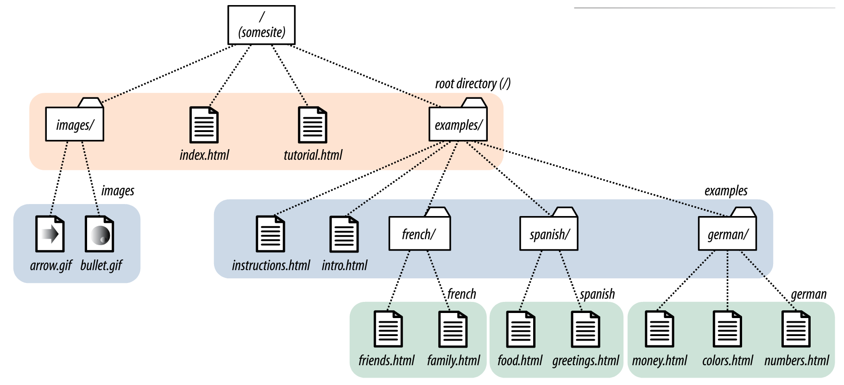

- For the index.html page shown above, write the HTML code to create an unordered list of hyperlinks to instruction.html, numbers.html, and tutorial.html. Then, write the HTML code to place the arrow.gif image below the list of hyperlinks.

<ul>
<li><a href= “examples/instructions.html”>Instructions</a></li>
<li><a href= “examples/german/numbers.html”>Numbers</a></li>
<li><a href= “tutorial.html”>Tutorial</a></li>
</ul>

<a src= “images/arrow.gif” alt= “arrow” >

- What has higher priority in the CSS cascade?
- id selectors #thediv { color: blue; }
- class selectors .adiv { color: blue; }
- tag name selectors div { color: blue; }

- Where can CSS code go (circle all that apply)?
  - <style src="here">
  - <style>here</style>
  - <p style="here">Content</p>
  - In a .css file
  - <link css="here">
Fill in the blank with the correctly spelled CSS property name.
- Makes text bold font-weight
- Change the background color
background-color
- Defines the space between an element's content and an element's box, i.e., the space inside the border.
padding
- Makes rounded borders
border-radius

- Fix the CSS syntax errors below. You can cross out code and add your correction below.
p {
padding 3px 4px;
}
strong {
text-indent: 3px;
}
h1 {
font-weight: bold;
font-family: Arial;
}
.box {
border: 1px solid red;
}
- How much bottom padding is defined below?
padding: 10px 7px; 10px

- How much right margin is defined below?
margin: 10px 7px 5px 1px; 7px

- How much total width would this box take up:
div.box {
width: 600px;
padding: 20px;
margin: 10px;
} 660px
- How much total width would this box take up:
div.box {
width: 800px;
padding: 30px 20px;
margin: 10px 8px 6px 4px;
border: 3px solid red;
}
800 + 20*2 + 8 + 4 + 3*2 = 800 + 40+ 12 + 6 = 858px
- Describe an example of when it is appropriate to use inline CSS?
When the style of an element is truly unique and not used anywhere else. In PHP code where you wouldn’t have to include the style anywhere else
- What are two different reasons to store CSS in a separate file and link it to many web pages?
(1) To create a consistent look-and-feel for a website.
(2) So you only have to change styles in one place
(3) More efficient as the style sheet gets downloaded once for the entire site, and the user may visit many pages.
Write the CSS code to do each of the following.

- Center div elements horizontally and set the width of each to 600px (do not center the text, but rather center the 600px wide section).

div {
margin: auto;
width: 600px;
}

- Give all elements with the class name “important” an bold font.

.important {
font-weight: bold;
}

- Make all hyperlinks red but only if they are nested in an element with the id name "main_menu"

#main_menu a {
color: red;
}

- Consider the following style definitions and indicate the color of the text below

p {color: red;}
b {color: green;}
p i {color: blue;}
b i {color: purple; }
b.hilite {color: pink; }
p#intro {color: orange; }

a. What color is text? purple
<p><b><i> text</i></b></p>
b. What color is text? green
<p><i><b> text</b></i></p>
c. What color is text? pink
<p><i><b class="hilite">text</b></i></p>
d. What color is text? purple
<p id="intro"><b><i>text</i></b></p>
- Consider this embedded CSS and HTML Code:
<style>
p {color: red}
b {color: orange}
i {color: yellow}
p b {color: green}
p i {color: blue}
p b i {color: purple}
</style>
<p>
<b><i>One</i> Two</b>
<u><i>Three</i><u>
<b>
<i style="color: pink;">Four</i>
</b>
Five
</p>
a. What color is the word “One”? purple
b. What color is the word “Two”? green
c. What color is the word “Three”? yellow
d. What color is the word “Four”? pink
e. What color is the word “Five”? red

Consider the following HTML and draw only the elements as a tree-like diagram. You do not need to draw the text nodes.
<body>
<h1>Heading</h1>
<div id="intro">
<h3>Section Heading</h3>
<p>Paragraph with a
<a href="page.html">link</a></p>
</div>
<table>
<tr><th>First</th><th>Last</th></tr>
<tr><td>Bill</td><td>Gates</td></tr>
<tr><td>Steve</td><td>Jobs</td></tr>
</table>
<form id="myform"></form>
</body>
- Draw the tree here

Shown in class

- Write the JavaScript code to append a submit button with the value OK to myform

*** Not covered yet

All these questions pertain to the PHP programming language
- All code must be inside special delimiters.
What is the start delimiter? <? Or <?php
- All variables must start
with a special symbol.
What is the symbol? $
- What function terminates execution and
guarantees a message will be printed? die
- What is an associative array?

An array where the index is a string. It is implement with hashing (hash table / hash map).

- What statement is used to "import" PHP code from a separate file?
include, require, include_once, require_once
- What keyword is used to definite functions?
function
- Functions must have a specified return type? T / F
- Write a function makeHeaders that takes two parameters (title and author) and returns a string with title inside of an h1 tag and author inside of an h2 tag.

function makeHeaders($title, $author) {
return ‘<h1>’.$title. ‘</h1><h2>’. $author. ‘</h2>’;
}
- Consider this function:

function db_connect () {
return new mysqli("localhost", "admin", "abc123", "trivia");
}

a. What does this function return exactly?
A database connection object

b. What is it connecting to?
The local host’s database server and the trivia database

c. What is "abc123"?

password of user

d. What is "trivia"?

name of database

- Consider this code?
$mysqli = db_connect();
$sql = "SELECT * FROM Questions";
$result = $mysqli->query($sql);
$row = $result->fetch_row();

a. What is $mysqli exactly, i.e., what kind of variable is it and what does it represent?

Database connection object

b. What is $sql exactly, i.e., what kind of variable is it and what does it represent?

String representing an SQL query

c. What is ->, i.e., what is it equivalent to in Java?

The dot operator

d. query and fetch_row are examples of?

methods

- Given the following database connection write all the code to select the password field and usertype field from the Users database WHERE username comes from a posted form element with the name usrname and then assign fetched password to a local variable and the fetched usertype to a session variable. Chose appropriate variable names and be sure to close all connections.

$mysqli = new mysqli("localhost", "sienasel_sbxusr", "abc123", "sienasel_sandbox");

$u = $_POST[‘usrname’];
$sql = “SELECT password, usertype FROM Users WHERE username = ‘$u’”;

$result = run_query($sql);

// $result = $mysqli->query($sql);

$row = $result->fetch_assoc();

$pass = $row[‘password’];

$_SESSION[‘usertype’] = $row[‘usertype’];
*** Not covered yet

- Write a while loop and foreach loop to print the following query result as an HTML table:

$mysqli = db_connect();
$sql = "SELECT * FROM Questions";
$result = $mysqli->query($sql);

echo '<table>';

// Fetch each row one at a time
while ($row = $result->fetch_row()) {

echo '<tr>';

// Loops for each column in a row
foreach ($row as $value) {
echo '<td>'.$value.'</td>';
}

echo '</tr>';
}
echo '</table>';

JavaScript vs. PHP
- Write a JavaScript function to create a drop down menu from an array called colors. The name of the drop down menu should be color.

*not covered yet

- Write a PHP function to do exactly the same thing but assume the array called colors is an associative array where the index is the name of the color and the value is the color code. Your dropdown menu should display the color name but use the color code as the option value.

echo '<select name= “color” >';

foreach ($color as $key => $value) {
echo '<option value="'.$value.'">'.$key.'</option>';

echo '</select>';

